Jiao B, Li R, Zhou H, Qing K, Liu H, Pan H, et al. Neural biomarker diagnosis and prediction to mild cognitive impairment and Alzheimer’s disease using EEG technology. Alzheimer's Research & Therapy. 2023;15(1):32.

During the last three decades, as pointed out in a recent study, more than 95% of the studies that focused on EEG-based classification of MCI or AD were conducted with fewer than 100 participants, making relevant findings unconvincing .

EEG signal was recorded at 200 Hz from the participants in a 10-min eye-closed resting state. Participants  
were required to remain awake during the entire recording. Standard 16-channels montage was utilized according to the 10–20 International System.

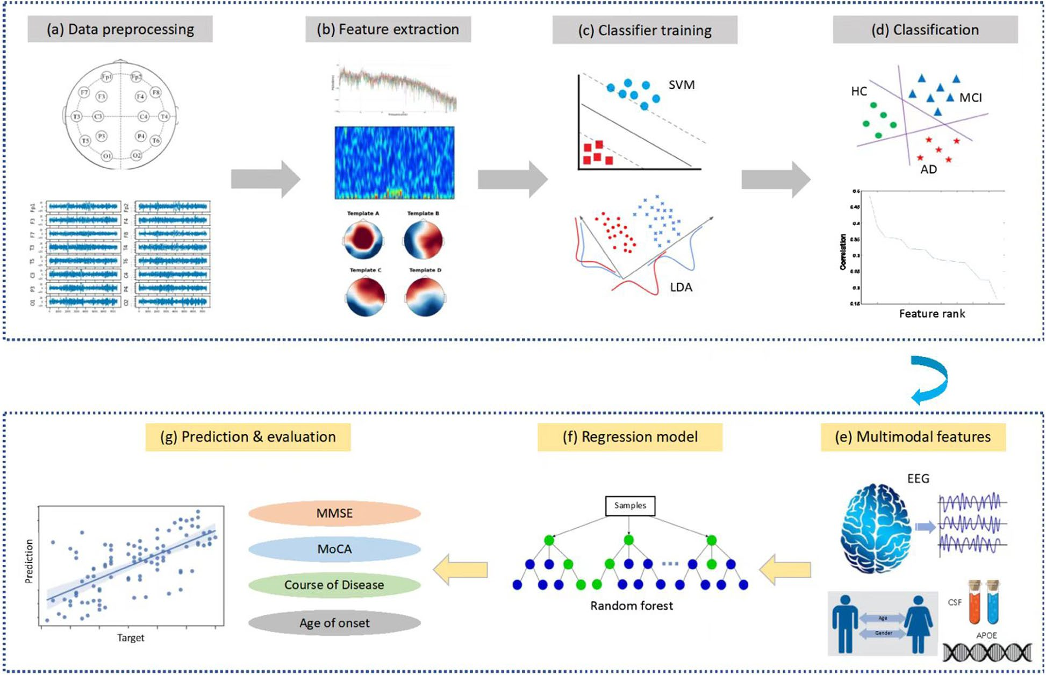

Future work is needed to evaluate the effectiveness of EEG techniques in diagnosing different types of dementias.

Longitudinal studies with large cohorts would be conducted in the future to assess whether EEG biomarkers can be used to trace the progress trajectory of AD or evaluate the efficacy of pharmacological/therapeutic interventions for AD patients.

reported in previous studies, patients with MCI and AD generally showed decreased alpha/beta power and increased theta/delta power in a broad range of brain regions such as frontal, temporal, parietal, and occipital areas

In this study, we addressed this challenge by recruiting a relatively large sample of healthy controls (246) and patients (189 MCI and 330 AD) in a clinical framework and achieved a decent three-level classification accuracy (over 70%)

The datasets generated and/or analyzed in the present study are available from the corresponding author upon reasonable request

Fouad IA, El-Zahraa M. Labib F. Identification of Alzheimer’s disease from central lobe EEG signals utilizing machine learning and residual neural network. Biomedical Signal Processing and Control. 2023;86.

proposed methods to detect Alzheimer’s disease from EEG signals acquired from a minimum number of electrodes: three central lobe electrodes.

Intro

There are limitations that affect the performance of Computer Aided Diagnosis (CAD) systems that detect Alzheimer’s from EEG signals. The inability to determine appropriate feature selection methods in the relevant literature studies or the failure to consider the EEG channels that carry important information are important factors for these limitations.

A wavelet transform reveals important information in a signal’s time–frequency domain through analysis of frequency components.

According to the report published in 2021, it is stated that 30% of people are misdiagnosed.

For the purpose of eliminating noise in the EEG data obtained from each electrode, the MSPCA method was used in the proposed study.

This implementation was conducted using a laptop with an i7-2.7 GHz processor Core (TM).

A technician was assigned during the recording to control the patient’s alertness. This EEG dataset is available as open source.

Method

After generating the features from the EEG signals, the next step is to create the 2-D plots of the obtained features. Then, tools from the MATLAB deep learning toolbox were used. “Resnet-50” model was constructed. Training of the model was done on 1200 plots (3000*0.40%) and the remaining 1800 plots were used to test and validate the model

comclusion

With the data set used in the study, a machine learning-based study has not been presented yet

Miltiadous A, Gionanidis E, Tzimourta KD, Giannakeas N, Tzallas AT. DICE-Net: A Novel Convolution-Transformer Architecture for Alzheimer Detection in EEG Signals. IEEE Access. 2023;11:71840-58.

This paper proposes a novel approach to AD EEG classification using a Dual-Input Convolution Encoder Network (DICE-net). Approach: Recordings of 36 AD, 23 Frontotemporal dementia (FTD), and 29 age-matched healthy individuals (CN) were used.

Our results show that DICE-net achieved an accuracy of 83.28% in the AD-CN problem using Leave-One-Subject-Out validation

EEG can capture neural events in the order of milliseconds , but its spatial resolution is limited by the number of electrodes used to record the electrical activity of the brain.

Due to the complex, non-stationary, and non-linear nature of the EEG signals, various efficient methodologies for feature extraction have been proposed for the different EEG problems. One of the most common ways to analyze the  
EEG signal is to decompose it into other frequency bands, such as delta, theta, alpha, beta, and gamma. Each frequency band represents a diverse range of electrical activity in the brain and is thought to be associated with different cognitive and physiological processes [18]. For example, the delta band (0.5-4 Hz) is often associated with deep sleep and the maintenance of bodily functions, while the alpha band (8-13 Hz) is thought to be related to attentional processes and relaxation [19]. Thus, the EEG signals are usually transformed to the frequency domain using a Fourier methodology such as Fast Fourier Transform (FFT) [20] or the Welch Power Spectral Density (PSD) [21] analysis or transformed to the time-frequency domain using decomposition such as the Discrete Wavelet Transform (DWT) [22] or the Empirical Mode Decomposition (EMD) [23]. Another way of analyzing the EEG signal that is becoming increasingly popular is coherence analysis and graph theory methods, as they provide powerful tools for investigating the functional connectivity and organization of the brain [24]. Coherence analysis is an approach that measures the degree of synchronization between different brain regions at specific frequency bands, providing information on the strength and patterns of functional connectivity. Graph theory methods are used  
to construct a network representation of the brain based on the coherence values, where nodes represent brain regions, and edges represent the strength of the coherence between them. By analyzing the topology and properties of the network, researchers can gain insights into the organization and dynamics of the brain, as well as its ability to process information [25]. Following the transformation or analysis of EEG data with one of the abovementioned methodologies, band power, entropy, fractal dimension, or statistical features are usually extracted to be fed to a Machine Learning framework for automatic detection, prediction, severity assessment, or evaluation of the given EEG task

In this study, we propose a novel methodology for classifying EEG signals from AD patients, combining a Convolutional Network architecture with a Transformer encoder on a dual feature/input scheme, namely Dual-Input Convolutional Encoder Network (DICE-net). Specifically, we extract two of the most promising biomarkers for AD detection, namely Relative Band Power (RBP) (literature has shown an increase in Theta/Alpha ratio in AD patients [39]) and Spectral Coherence Connectivity (SCC) (literature has shown decreased synchronization likelihood in AD patients [40]), and we express them in image-like representations (3d matrixes) which were fed in 2 parallel Convolution blocks. The Convolution blocks reduced the dimensions of these features extracting relevant information. The outputs were fed to 2 parallel Transformer Encoder blocks, along with randomly  
initialized CLS tokens used to conceptualize the sequence content. Finally, a Feed-Forward Neural Network (FFN) was trained to classify the instances as AD or healthy. The model was also evaluated using a group of FTD patients to explore its generalizability potential to other dementia types. It should be noted that this methodology is proposed considering AD classification performance optimization. In order to propose a scheme that best classifies FTD cases, more experimentation should be conducted

Methods

The analysis of the proposed methodology for the automatic classification of AD EEG signals versus Control EEG signals consists of four stages: data acquisition, signal denoising, feature extraction, and classification.

To evaluate the proposed methodology, recordings from 88 participants were acquired from the 2nd Department  
of Neurology of AHEPA General University Hospital of Thessaloniki. 36 (13 males) of them were diagnosed with  
Alzheimer’s disease (AD group), 23 (14 males) were diagnosed with Frontotemporal Dementia (FTD group), and  
29 (11 males) were healthy subjects (CN group)

The preprocessing pipeline of the EEG signals is as follows. First, a Butterworth band-pass filter 0.5-45 Hz was applied, and the signals were re-referenced to A1-A2. Then, the ASR routine [12] which is an automatic artifact reject method that can remove transient or large-amplitude artifacts

First, each recording was divided into 30-second time windows with 15 seconds overlap to create the pool of EEG  
signals that will be used for the classification task. Next, the following two features (described in sections II-C1. and  
2.3.2.) have been extracted for T = 30 one-second periods, for each channel of the EEG signal (C=19), for each of the B=5 frequency bands, which describe the five brain rhythms of interest of the EEG signal. So, in total, two 3-dimensional arrays of dimensions [T,B,C] were generated for 30-second time-window.  
The five frequency bands of B were defined as:  
Delta: 0.5 – 4 Hz  
Theta: 4 – 8 Hz  
Alpha: 8 – 13 Hz  
Beta: 13-25 Hz  
Gamma: 25-45 Hz

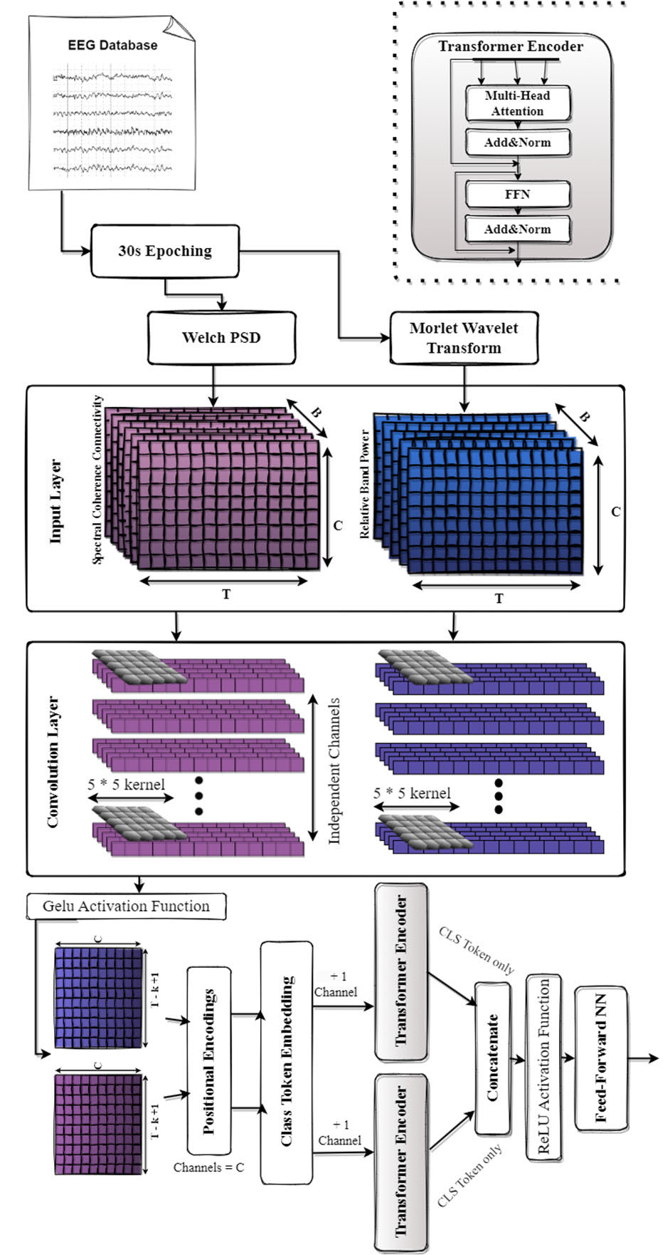

We made the dataset publicly available, allowing other researchers to evaluate different models and use this research as a benchmark

The performance results of ACC=83.28% and F1=84.12% suggest that the DICE-net model can effectively capture EEG-derived feature vectors’ spectral and spatial patterns and extract meaningful dependencies for classification.

Nour M, Senturk U, Polat K. A novel hybrid model in the diagnosis and classification of Alzheimer's disease using EEG signals: Deep ensemble learning (DEL) approach. Biomedical Signal Processing and Control. 2024;89.

Public EEG-based Alzheimer’s datasets have been classified in the DEL model without applying any feature extraction after cleaning from noise and artifacts.

The proposed DEL model reached an average accuracy of 97.9% in AD classification due to 5 cross-fold training.

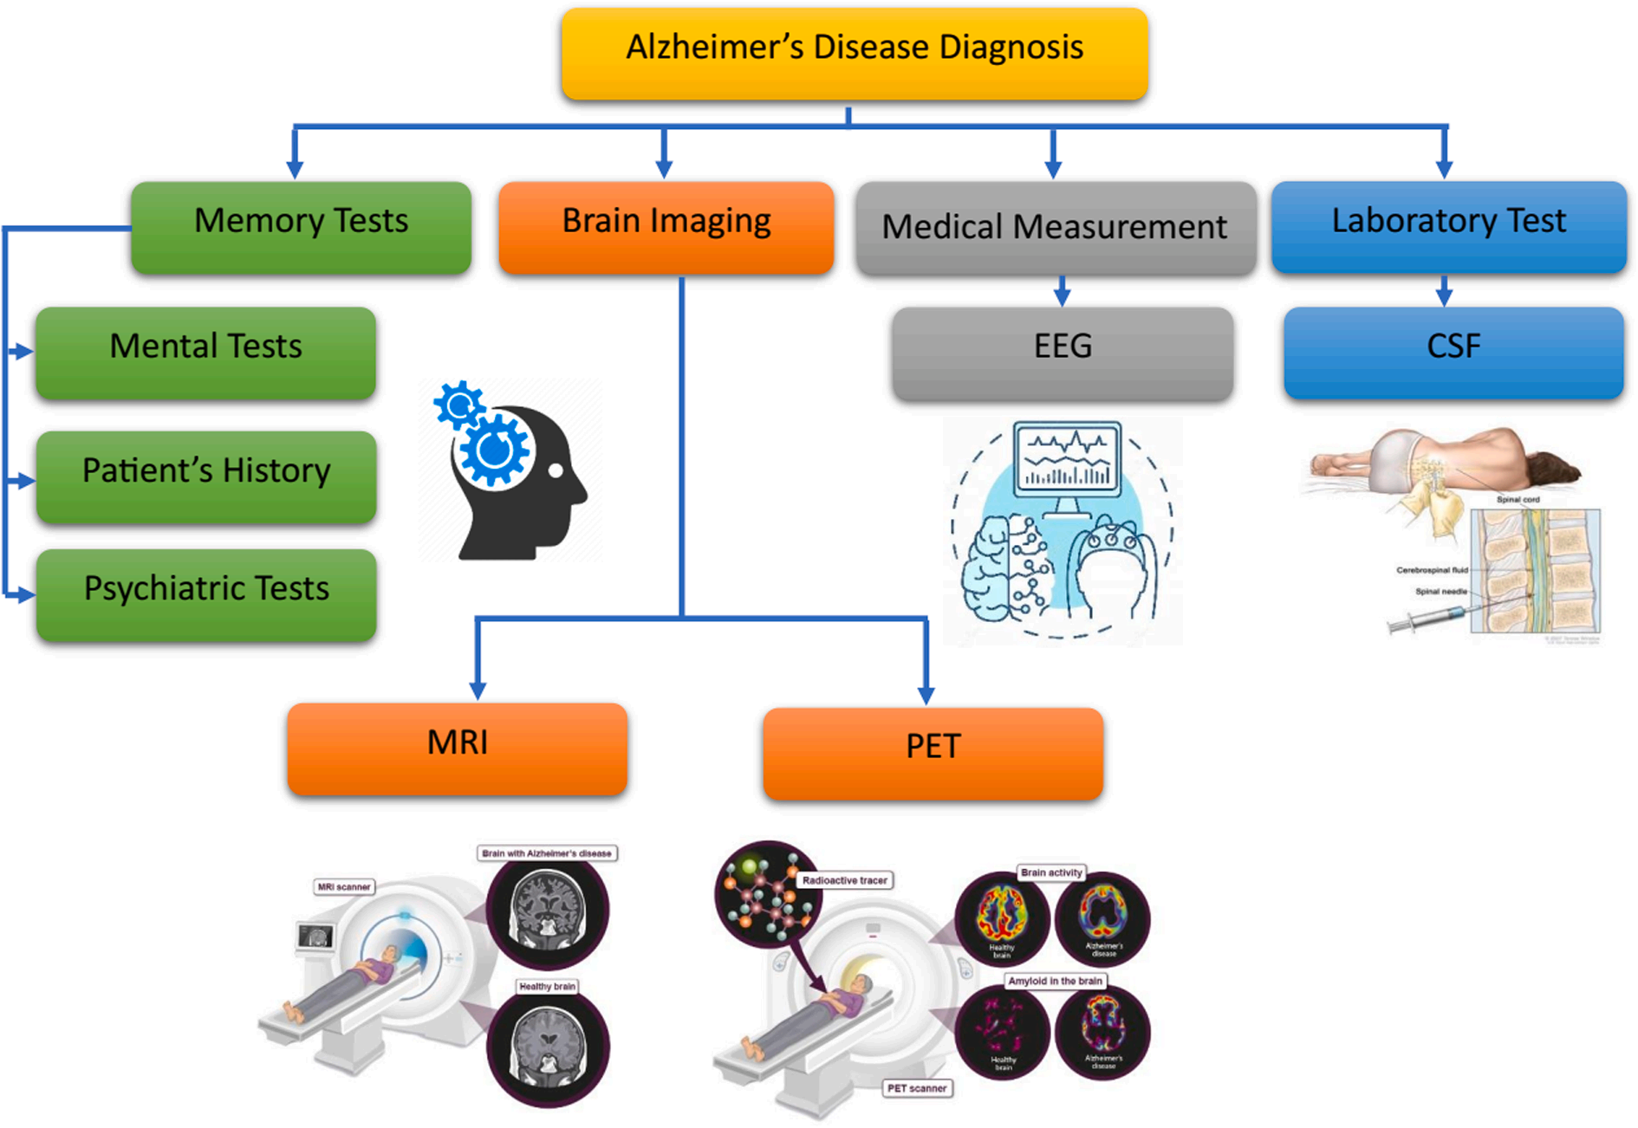**Fig. 1.** AD diagnosis methods.

Electroencephalography signals (EEG) are a method of detecting electrical activity in the brain. It diagnoses various neurological and medical conditions, including AD [19]. During the early stages of AD, EEGs can be used to detect changes in brain activity related to the disease. These changes can include increased slow brainwaves (delta and theta waves) [20] and decreased faster waves (alpha and beta waves) [21,22]. EEGs can detect these changes even before the onset of physical symptoms. EEGs provide a valuable tool to diagnose and monitor AD. Furthermore, EEGs can be used to monitor changes in brain activity associated with the progression of the disease and help doctors adjust treatments and make better decisions.

The advantages of SVM include its ability to minimize data overfitting, its robustness in large datasets, and its ability to accommodate multiple classes. The disadvantages of SVM include its high computational cost and potential difficulty in tuning parameters [28,29]. Random forests (RF) The advantages of RF include its ability to handle various data types, its flexibility in tuning model parameters, and its ability to predict probabilities accurately. The main disadvantages of RF include its timeconsuming nature and lack of interpretability [30–32]. Deep learning models as a one-dimensional convolutional neural network 1D-CNN [33], convolutional neural network (CNN) [34–36]. The advantages of CNNs include their ability to handle large amounts of data, their accuracy in predicting complex patterns, and their power in processing visual data. The disadvantages of CNNs include the computational cost associated with training them, the difficulty verifying their predictions, and reliance on labeled data.

We can address the following gaps in the paper:

Effectiveness of different EEG signal standards for AD diagnosis: The  
paper compared and evaluated different EEG signal processing techniques or standards to determine their effectiveness in accurately diagnosing AD [28,44]. This may help determine the most reliable and practical approach to using EEG signals as a diagnostic  
tool for AD

Lack of studies using hybrid models [41,45]. The authors emphasized the scarcity of studies that combine multiple EEG frequency  
bands to diagnose and classify Alzheimer’s Disease.  
Limited use of deep ensemble learning in EEG-based AD classification: The paper discusses the limited use of deep ensemble learning  
approaches in EEG-based AD classification. It is explained how their new model fills this gap by using a deep ensemble learning approach  
to improve classification performance. When the literature was examined, the use of the deep ensemble learning (DEL) model in AD  
diagnosis and classification using EEG signals was not found.  
• Lack of generalization to different data sets [46,47]: The paper emphasizes the difficulty of generalizing the results from one data set to  
different data sets. Potential limitations of their study in terms of  
dataset specificity are discussed.

Insufficient investigation of feature importance [48,49]: The paper examined the feature importance analysis of different frequency  
bands in AD diagnosis in more depth. Each frequency band’s potential biological significance and relevance to AD pathology is  
discussed.

This article used a public EEG-based AD diagnostic, two different datasets created by researchers at Florida State University. The dataset  
was passed through a Butterworth band-pass filter to remove noise and artifacts

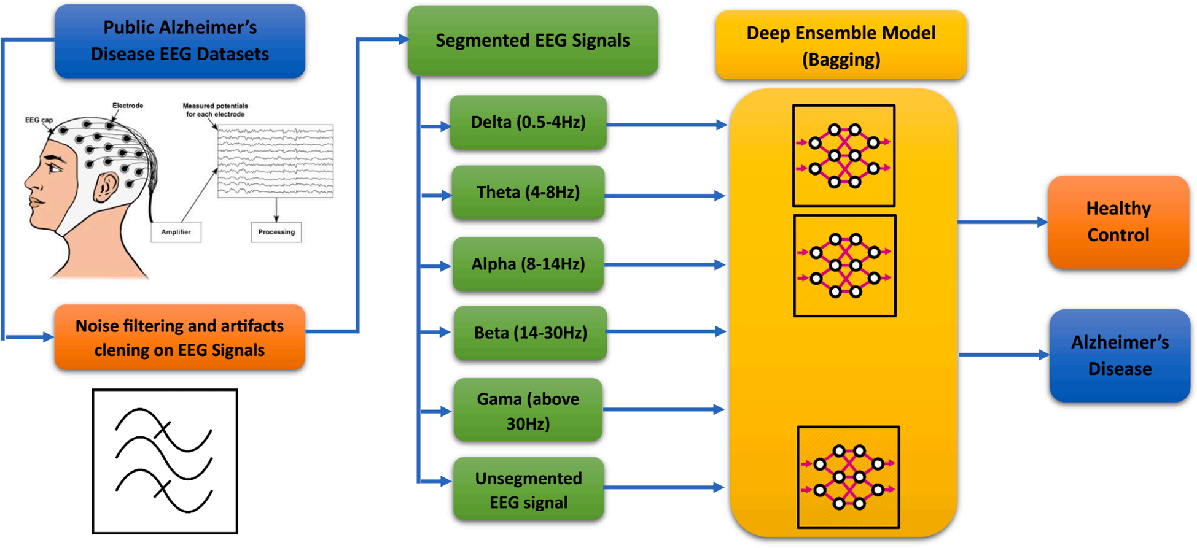**Fig. 2.** Block diagram AD diagnosis DEL model system [56].

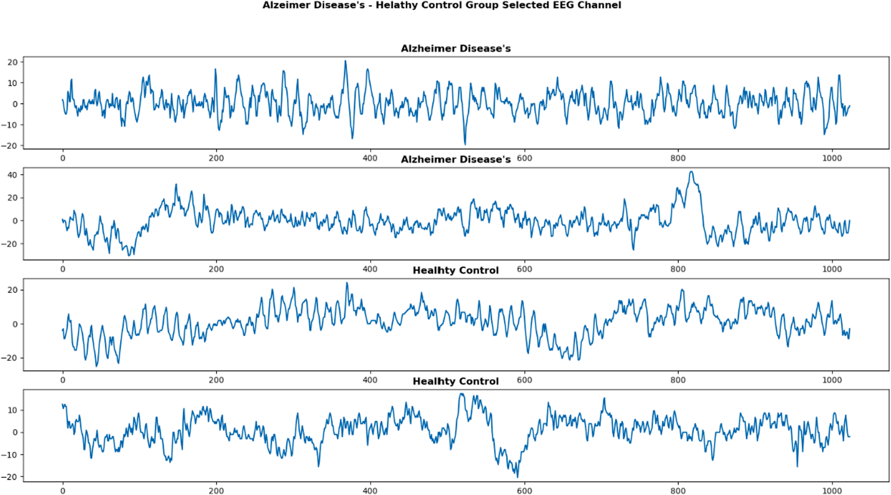**Fig. 3.** Alzheimer Disease’s (AD) – Healthy Control (HC) Group EEG signals.

EEG signals are usually divided into five frequency bands: Delta, Theta, Alpha, Beta, and Gamma [65]. The Delta band is associated with  
the deepest level of sleep and coma. It is typically below 4 Hz. The Theta band is typically 4–8 Hz and is associated with teenagers and adults in the first stage of sleeping, daydreaming, and relaxation. The alpha band is typically 8–14 Hz and is associated with light sleep, relaxation in adults, and deep concentration in teenagers. The Beta band is typically 14–30 Hz, associated with alert states and higher cognitive functioning. Finally, the Gamma band is typically 30 + Hz and is associated with the highest level of conscious awareness.

Certain EEG bands may be particularly useful for diagnosing and classifying AD. Specifically, the Theta and Alpha bands are related to  
cognitive functioning, particularly affected in AD. Decreased Theta activity has been reported for mild and moderate stages of AD [66],  
whereas Alpha activity may be decreased during mild AD, and further decreases are observed with increasing severity. In addition, an  
increased Theta/Alpha ratio has also been reported for subjects with mild AD compared to HC subjects [67]. EEG signals may also reveal  
abnormal neural activity associated with AD. Specifically, some studies have reported increased Delta activity in mild to moderate stages of the disease [68]. This suggests that this EEG band can be used as an early indicator of cognitive impairment due to AD. In addition, increased high-frequency activity in the Beta and Gamma bands has been reported in AD patients compared to HC subjects. This suggests that these EEG bands can give valuable insight into the nature of the neural activity affected by AD. Finally, various EEG measures, such as spectral power, have been used to differentiate AD subjects from HC subjects. In particular, several studies have found increased Delta/Theta power in AD subjects compared to HC subjects [69]. This suggests that EEG spectral power measures may be valuable for AD diagnosis and classification

This paper divides EEG signals into 5 frequency bands with a Butterworth band-pass filter. EEG signals recorded as 8 s in the datasets  
were segmented into 1 s epochs. An epoch was converted into a 2D array of 128x19. A total of 1120 epochs consist of two datasets combined. Then, EEG signals for each frequency band (delta, theta, alpha, beta, and gamma) were segmented into 1 s epochs (128x19 2D array) and given as input to ensemble learning.

DEL is a supervised machine learning technique that combines the predictions of multiple deep learning models

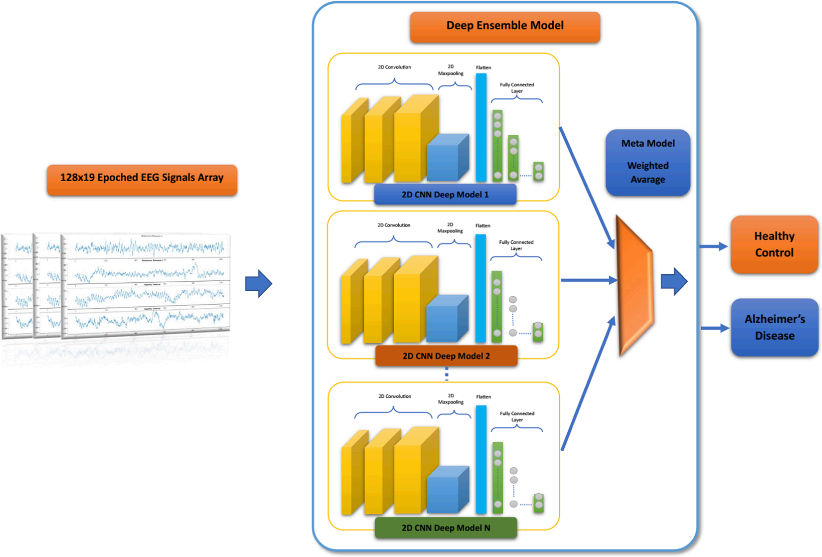**Fig. 4.** The proposed Deep Ensemble Learning (DEL) Models for AD-HC Classification.

The proposed DEL model is used to identify AD from EEG signals. Fortunately, there are many areas for improvement in future work. First, the model’s accuracy can be further improved using regularization techniques. For example, combining DEL with evolutionary-based optimization techniques can help find optimal hyperparameter settings. Second, the proposed model lacks interpretability, and it is essential to use explainable Artificial intelligence (AI) techniques such as rule extraction to understand the model’s decision-making process. Finally, the proposed model can be extended to several other neurological disorders, such as Parkinson’s, epilepsy, and stroke, to diagnose and classify various diseases. A combined approach combining multiple modalities (EEG, MRI, PET) can also be used to build a robust deeplearning model for diagnosing neurological diseases.

When Table 11 is examined, it is seen that AD EEG data sets are divided into three classes in general. These are AD, HC, and MCI.  
Considering the complexity of EEG signals, classifier models should be reduced to more straightforward features that can be calculated. In studies in the literature, AD has been classified in artificial intelligence classifier models by extracting different features from EEG signals. It is seen that different numbers of subjects are used in AD classification literature studies. These subjects were determined as AD, HC, and MCI by scoring the memory tests and brain imaging methods. Although the artificial intelligence models used in AD classification reach different accuracy rates, the proposed DEL model has reached a remarkable accuracy value. With 5 cross-fold training, the average accuracy of the DEL model reached 97.9% ± 1.1%. It will enable the DEL model to reach higher accuracy with future studies’ best internal classifying modelselections.

In this paper, we have used this first dataset: (A. S. L. O. Campanharo, F. M. Ramos, A. M. Pineda, and L. E. Betting, “Data from: Quantile  
Graphs for EEG-Based Diagnosis of Alzheimer’s Disease,” 2020, doi: 10.17605/OSF.IO/S74QF, online: https://osf.io/pa38y) We can send  
the datasets at the request of the authors.   
Second dataset : (Vicchietti, Mario ´ L., Ramos, Fernando M., Betting, Luiz E., Campanharo, Andriana S. L. O.”Data from: Computational  
methods of EEG signals analysis for Alzheimer’s disease classification”2023, 10.17605/OSF.IO/2V5MD, online: https://osf.io/2v5md/?  
view_only=). We can send the datasets at the request of the authors.

Sibilano E, Brunetti A, Buongiorno D, Lassi M, Grippo A, Bessi V, et al. An attention-based deep learning approach for the classification of subjective cognitive decline and mild cognitive impairment using resting-state EEG. Journal of Neural Engineering. 2023;20(1):016048.

Five different datasets were created by extracting delta, theta, alpha, beta and delta-to-theta frequency bands using bandpass filters.

Results showed that the delta dataset allowed our model to achieve the best performances for the discrimination of SCD and MCI, reaching an Area Under the ROC Curve (AUC) of 0.807, while the highest results for the HC *vs* SCD *vs* MCI classification were obtained on alpha and theta with a micro-AUC higher than 0.74. *Significance.*

It is now known that biological markers, such as amyloid-beta (A*β*) protein accumulation, which is distinctive in AD, may be found in the brain up to 20 years before the stage of dementia [5].

In this context, it has been established that SCD can occur at late stages of preclinical AD, before MCI is reached. This phase can be also referred to as pre-MCI or preprodromal AD.

Nonetheless, SCD constitutes a heterogeneous group, as it could be related to conditions such as normal aging, personality traits, psychiatric conditions, neurological and medical disorders, substance use, and medication [16]

Results on separate validation datasets indicated an estimated probability of A*β* positivity of up to 0.75 for patients with MCI and of 0.60 for SCD subjects

Although the task of classifying SCD and MCI subjects from HCs has been addressed in several studies [21, 22], the discrimination between SCD and MCI conditions from a functional point of view is still poorly investigated in literature since anatomical and functional changes in brain between the two classes are subtler, making it a more challenging task to deal with.

using 18F-fluorodeoxyglucose positron emission tomography (PET), it was found that subjects with SCD show glucose and neuronal hypometabolism

A more comprehensive review of research in this field can be found in the work by Babiloni *et al* [32]. Cassani *et al* summarized EEG changes related to AD progression into four main categories: slowing, complexity reduction, synchronization decrement and neuromodulatory deficit [33].

A more comprehensive review of  
research in this field can be found in the work by Babiloni *et al* [32]. Cassani *et al* summarized EEG changes  
related to AD progression into four main categories: slowing, complexity reduction, synchronization  
decrement and neuromodulatory deficit [33].

Changes in relative and absolute power of theta (*θ*)frequency band appear to be significant among AD,  
MCI and HC at individual level [35]. Significantly higher global delta (*δ*) and theta power, lower global  
alpha (*α*) power and a higher global peak frequency

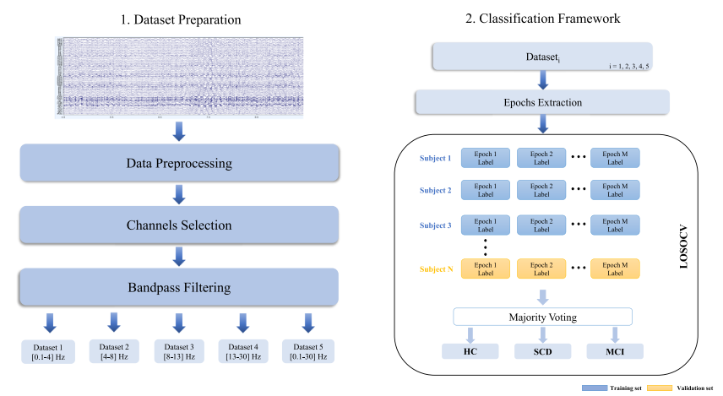**Figure 1.** Workflow of the proposed method. Firstly, raw EEG signals are preprocessed. Then, 19 channels are selected and 4  
frequency bands (*δ*, *θ*, *α* and *β*) are extracted, obtaining four distinct datasets and a fifth one using the *δ*-to-*β* range. After  
epoching the signals, we perform both two- and three-class classifications of epochs through LOSOCV. Finally, a majority voting  
approach is used to label each subject in the test set either as HC, SCD or MCI based on the class assigned to its epochs.

DL enables end-to-end learning from raw inputs, thus overcoming the limitation of processing highdimensional volumes of data encountered by traditional machine learning (ML) approaches.

Compared with convolutional neural networks (CNNs) and recurrent neural networks (RNNs), which are the most extensively used architectures for time-series data classification [38], transformers [39] haveshown higher ability to deal with long-range dependencies and recognize patterns in sequences of data [40], as well as employ more interpretable decision-making processes [40, 41]. Although transformers have become the standard models in natural language processing (NLP), recent efforts in exploring their applications on timeseries data, such as EEG or electromyography signals,are showing interesting results [42]

In this work, we propose a DL framework based on the transformer model for the binary classification  
of resting-state EEG signals of SCD and MCI patients.  
To the best of our knowledge, this is the first study applying DL to EEG in a well-characterized clinical population at risk for AD, as MCI and SCD patients. The same framework is then employed to  
perform a multiclass classification among HC, SCD and MCI. Figure 1 shows the implemented workflow. We exploited the power of self-attention mechanism to extract relevant information from the signal in the temporal domain. Specifically, we firstly preprocessed the EEG signals with a well-consolidated,standardized pipeline [43]. Then, we filtered clean EEG signals to extract four main frequency bands, each used to build a new dataset from the original one. An additional dataset was obtained by filteringthe signals in the full delta-to-beta range [0.1–30] Hz. Employing a leave-one-subject-out cross-validation(LOSOCV) approach, we trained and tested a model on each dataset to label the subjects based on their brain activity. Then, we compared the obtained results with three CNN-based models, both for the binary and multiclass classification tasks.

Indeed, none of the above cited studies addressed the SCD *vs* MCI classification task by using DL  
approaches. Thus, we adapted an end-to-end model mainly employed in NLP, the transformer, and the  
self-attention mechanism, to classify resting-state EEG signals in a dataset of HC, SCD and MCI subjects by focusing on the global patterns of the brain oscillatory activity.

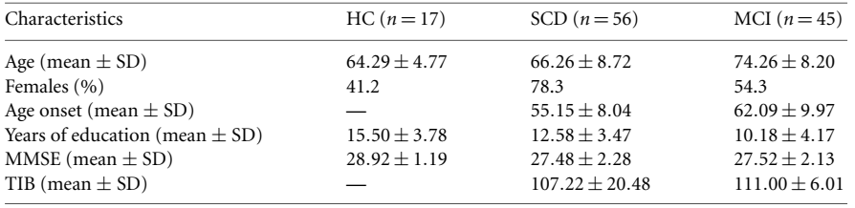

Clinical-demographic characteristics of the study population. HC: healthy controls; SCD: subjective cognitive decline; MCI:  
mild cognitive impairment; MMSE: mini-mental state examination; TIB: Italian brief intelligence Test; SD: standard deviation.

Data were acquired using EBNeuro’s GalNt system (EBNeuro, Florence, Italy) with 64 channels digitized at a sampling rate of 512 Hz. Among the 64 electrodes, 61 electrodes covered the whole scalp to record EEG while the remaining ones recorded electrooculographic and electrocardiographic activity, and thus were not considered for further analysis. The electrodes were placed according to the 10–10 montage system and electrode-skin impedance was set below 5 kΩ. Subjects were sat in a reclined chair for approximately 20 min.

A cluster of 19 channels, namely Fp1, Fp2, F7, F3, Fz, F4, F8, T3, C3, Cz, C4, T4, T5, P3, Pz, P4, T6, O1, O2, was then selected. Since these channels evenly cover the scalp area, this EEG pattern is the most employed in the literature for similar studies [56] and has been proven to ensure sufficient quality along with possible comparison with previous rsEEG findings of other projects [30]. Subsequently, the signals were bandpass filtered between 0.1 Hz and 45 Hz.

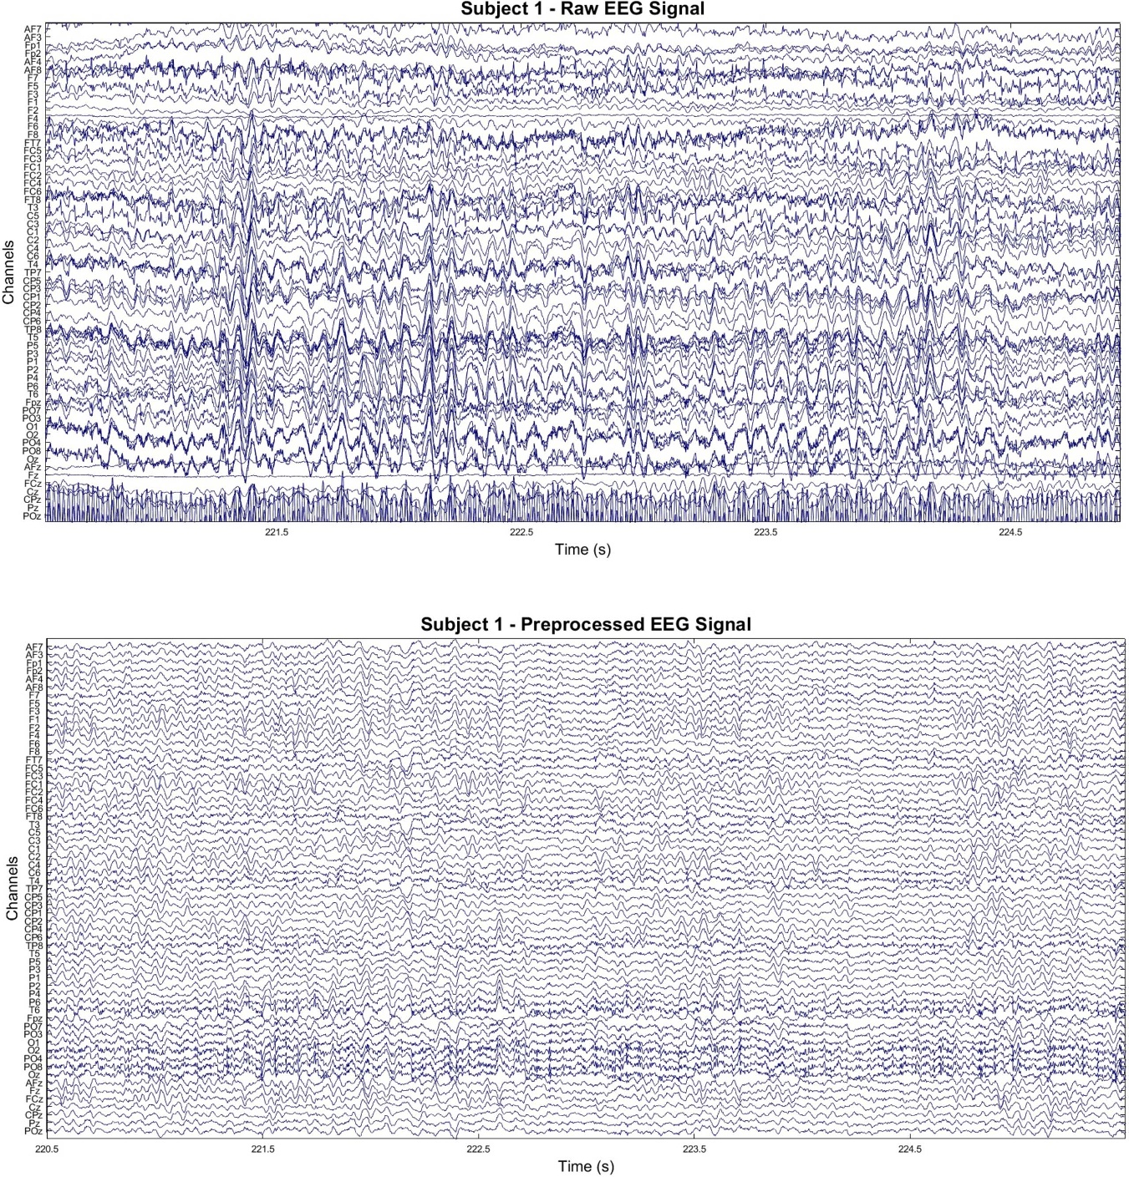**Figure 2.** Sample EEG recordings of subject 1. (top) 5 s window of raw EEG signal. (bottom) Same window after preprocessing.

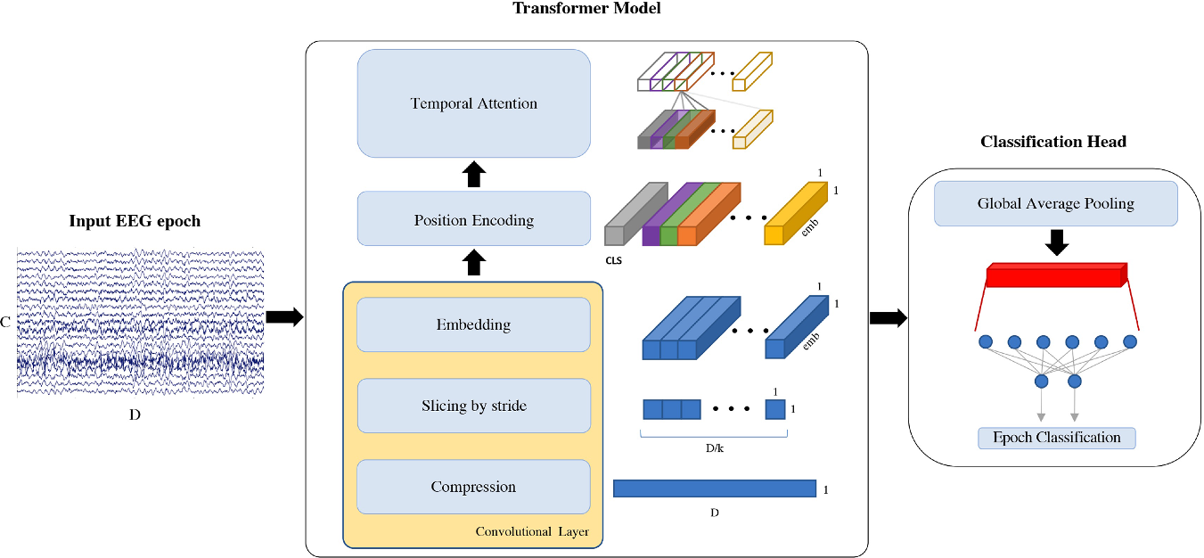EEG epoch classification pipeline. Each EEG segment of *C* = 19 channels and *D* = 5120 datapoints is used as input to  
our model, which uses a convolutional layer to compress the signal, extract slices and embed the information. *k* = 31 is the size of  
the kernel, emb = 6 is the embeddings’ dimension and CLS is the classification token prepended to the input. Attention  
mechanism is then applied on the temporal domain and, after global average pooling, a linear layer is used to classify the input  
EEG epoch

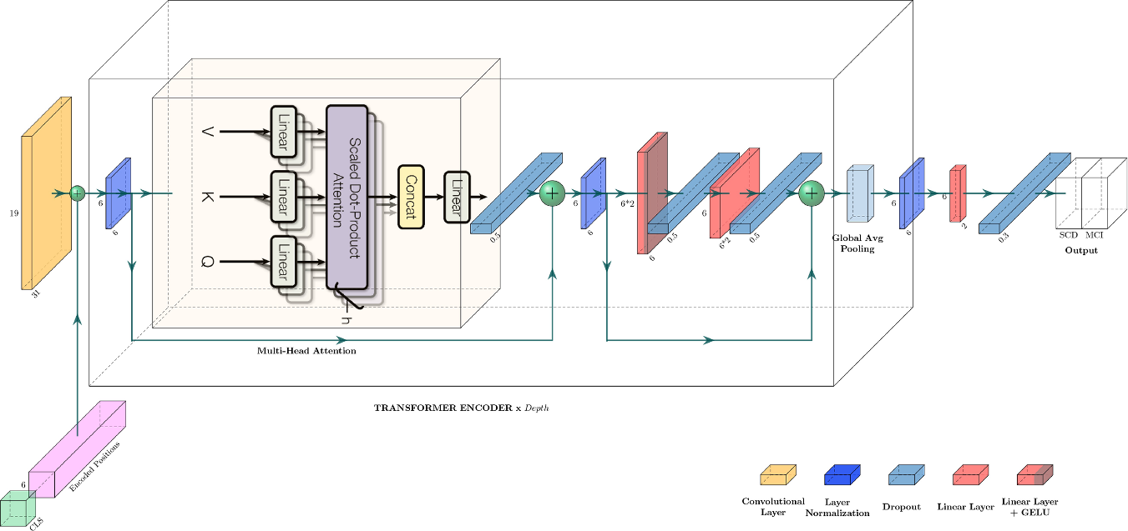**Figure 5.** Proposed transformer architecture. CLS is the classification token, *h* = 3 is the number of heads used by multi-head  
attention and Depth = 2 indicates the number of times the transformer encoder block is repeated. A legend for uncaptioned  
blocks is provided on the bottom right corner

we found that adding more spatial details by using all available 61 EEG channels, instead of a cluster of 19 channels, not only did not improve the performances of the model

Our results uphold this evidence, showing that changes in delta and theta are particularly useful in  
characterizing the brain activity of subjects affected by SCD or MCI, both when compared to other common EEG rhythms and to the all-band dataset, which includes the signals filtered in the range [0.1–30] Hz

On the other hand, we found that adding more spatial details by using all available 61 EEG channels,  
instead of a cluster of 19 channels, not only did not improve the performances of the model

On the other hand, we found that adding more spatial details by using all available 61 EEG channels, instead of a cluster of 19 channels, not only did not improve the performances of the model

In particular, the boundary between SCD and MCI, which is the first clinically diagnosed stage of the disease, is very blurry

Nonetheless, a further improvement of the proposed model, which could include the application of a spatial attention module on the EEG channels, is worth exploring. Moreover, a deeper interpretation of the results of this study could be provided by leveraging the attention weights in order to better understand the model’s decision processes. Future works may also focus on novel approaches for signal analysis and processing for classification pipelines, in order to remove all the irrelevant information from the input signals. Finally, the availability of a larger cohort of subjects would allow to further assess the effectiveness of our method and improve its generalization capabilities

The data cannot be made publicly available upon publication because they are owned by a third party  
and the terms of use prevent public distribution. The data that support the findings of this study are available upon reasonable request from the authors.

1. Perez-Valero E, Lopez-Gordo MA, Morillas C, Pelayo F, Vaquero-Blasco MA. A Review of Automated Techniques for Assisting the Early Detection of Alzheimer’s Disease with a Focus on EEG. Journal of Alzheimer's Disease. 2021;80(4):1363-76.

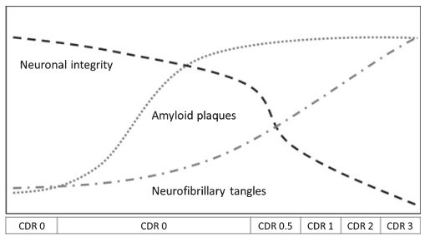

Fig. 1. Progression of the stages of AD regarding the evolution of the hallmark biomarkers and neuronal integrity. The dotted line refers to the appearance of amyloid plaques. The dashed and dotted line corresponds to the accumulation of neurofibrillary tangles and the dashed line represents neuronal integrity. Vertical and horizontal axes correspond to intensity and time. Each stage is assigned a Clinical Dementia Rating (CDR) value according to the severity of the disease in that stage. The first stage corresponds to the NonAD period and has a CDR score of 0. The second stage refers to Preclinical AD and has a CDR score of 0. In this phase, amyloid plaques start forming in the brain for more than a decade, starting the neuronal decay. The last four stages represent MCI, mild AD, moderate AD and severe AD and have CDR scores of 0.5, 1, 2, and 3 respectively. This graph has been inspired by the work of Perrin et al. [17].

Below, we briefly outline these techniques.  
• *Cognitive tests.* (MMSE), MoCA)

*Biomarkers : CSF,* CSF is a fluid located in the brain and the spinal cord that is extracted via lumbar puncture, a costly, scarce, and painful clinical technique

*Medical imaging.MRI,SPECT, PET*

*Neurophysiology: EEG,MEG*

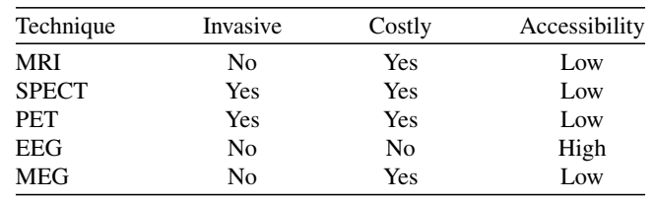 Comparison of the medical techniques described in the Introduction section

features like complexity, coherence, or spectral power are usually extracted from the time and frequency domains

In the case of medical imaging techniques, images are typically segmented into voxels and features are extracted  
from them EEG is processed in the time and the frequency domains.